NATIONAL OFFICE / BUREAU NATIONAL
14 Chamberlain Avenue Suite 200
Ottawa, Ontario K1S 1V9
Telephone: (613) 567-0311
Fax: (613) 567-2728
Toll Free: 1-877-304-0968
E-mail: ccb@ccbnational.net
www.ccbnational.net

April 18, 2024

Ref: Consultation on Requests for Conditional Exemption from the ATPDR.
Submitted by: The Canadian Council of the Blind.

In representing the Canadian Council of the Blind we feel that the Canadian Air Transport Security Authority (CATSA) and the Canadian Border Security Agency (CBSA) should NOT be exempt from the requirements of the Accessible Transportation for Persons with Disabilities Regulations (ATPDR) regarding tactile signage for security screening, and border clearance, of passengers respectively.
We do understand the difficulties of providing tactile signage when the current signs are large and filled with information and we do agree with the tactile booklet, providing it has large print, braille, Tactile pictures and follows standards around plain language, font, and colour styles.
We bring to your attention recently adopted standards for Braille Signage - Approved by Braille Literacy Canada, February 2024.
See paper attached.
We would like to emphasize that this booklet is an OPTION, another means of communication and it should not replace the need to still have accessible wayfinding techniques for signs or types and styles of signs being used. If CATSA and CBSA are fully exempt from this requirement then they could possibly be exempt from any future technologies being developed regarding accessibility of signs and wayfinding techniques.
We bring to your attention that there are techniques for dealing with accessible signs. Electronic signs are used in the built environment and in outdoor public spaces to communicate to a wide audience. They display pre-recorded content but may also offer the option of public live broadcast. These types of signs accomplish the same functions as traditional signs. They offer information, warn against hazards, identify the purpose or function of a point of interest, serve a regulatory aim, market a service or goods or assist in wayfinding. In providing wayfinding, signs display information which can:
· Help persons to orient themselves in relation to a given position,
· Communicate directions to travel between two points,
· Help a person to determine, to plot or to follow a route and help a person to identify and learn about a point of interest
We would also like to emphasize that the booklet be readily available to a person with vision loss, blindness or anyone requiring it upon entering the border screening area. There needs to be on-hand multiple copies of the booklet, so no passenger goes without the information they need or is refused access to the booklet.

Kind Regards
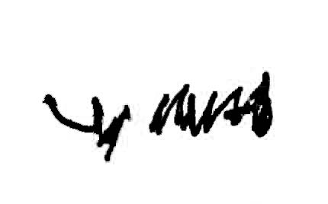
Leo Bissonnette Leslie Yee
National Board Member​s
Canadian Council of the Blind
National Office
14 Chamberlain Ave Suite 200
Ottawa, ON
K1S 1V9
613-567-0311
Toll-Free:1-877-304-0968
www.ccbnational.net

