**Closed-Circuit Television – Descriptive Text**

It's a square board with large yellow and white lettering containing a message in English and

repeated in Braille on a second page. The yellow text is "Closed-Circuit Television” and in brackets it says CCTV. The white text is “This area is monitored by video camera. The information is collected by the Canadian Air Transport Security Authority and used in accordance with the Government of Canada Privacy Act. For further information contact 1-888-294-2202.”

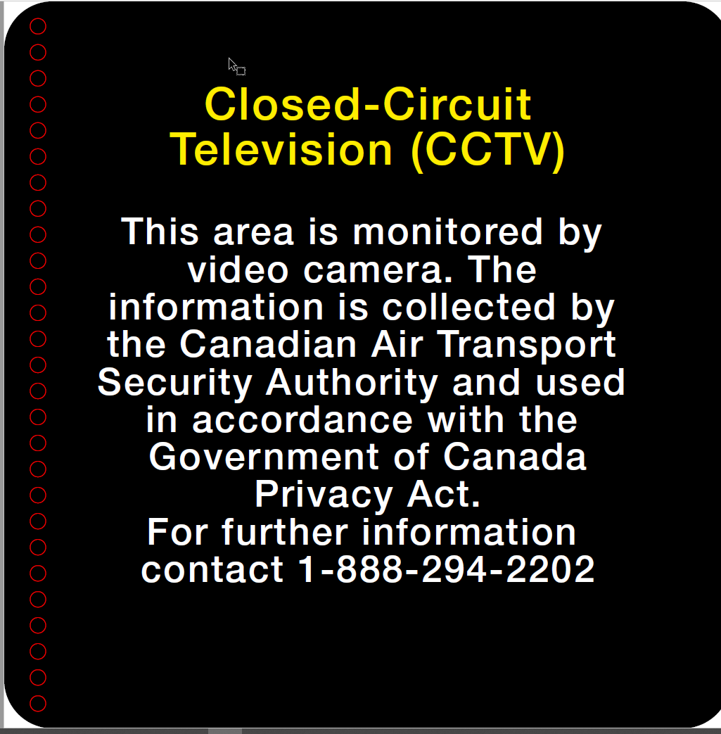

It's a square board with braille.

