Checked Baggage – Descriptive Text
It's a square board with large yellow and white lettering containing a message in English and
repeated in Braille on a second page. The text in yellow is a title that says "Checked Baggage” Below the yellow title is text that says “tagged only Please place checked baggage on conveyor belt. Lay bags flat. Wheels facing up. All 1m (3ft.) of space between bags. Proceed to the Screening Officer and await further instructions.

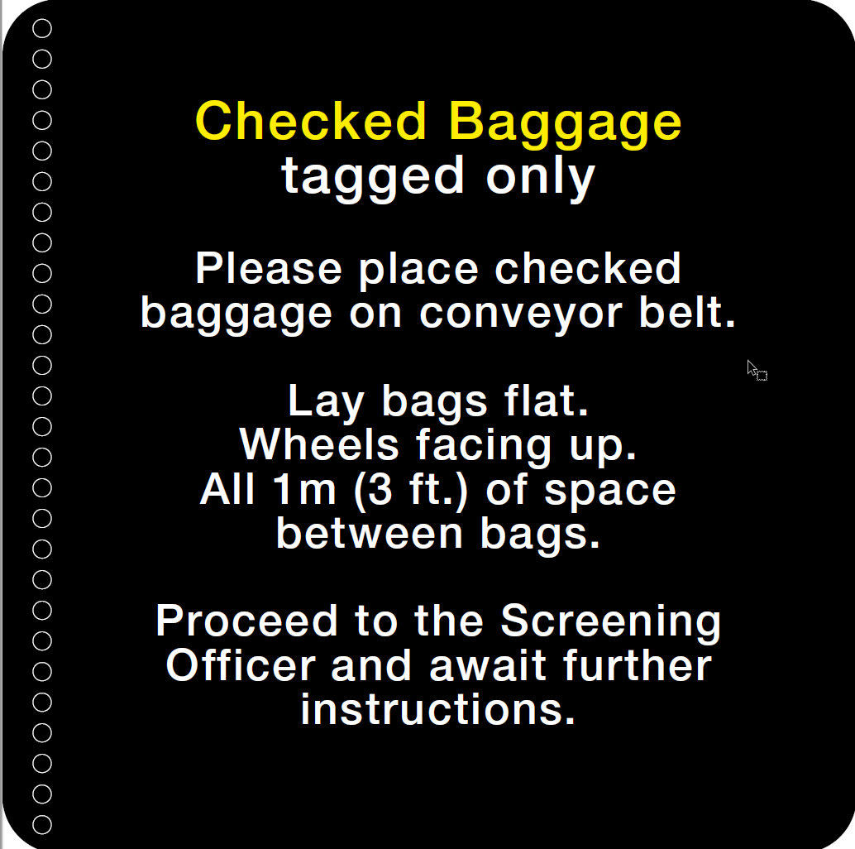

It's a square board with braille.

