Canadian Air Transport Security Authority
Unclassified

VIA EMAIL (secretariat@otc-cta.gc.ca)

October 30, 2023

Secretary, Canadian Transportation Agency
60 Laval Street, Unit 01
Gatineau, Québec
J8X 3G9

RE: Case 23-33996 - Application for exemption from s. 235(1) of the ATPDR

Thank you for your letter dated September 1, 2023. Before responding to the CTA’s specific questions, the following background may assist the CTA in understanding the framework and constraints applicable to CATSA signage.

As a government Crown Corporation, CATSA is subject to the Treasury Board of Canada Secretariat’s Federal Identity Program. This means that CATSA must follow certain standards and policies when using identifiers. It also means that certain kinds of signage must conform to a specified look set out in the Federal Identity Program Manual.

Aerodromes must, pursuant to s. 30 of the Canadian Air Transport Security Authority Act, grant CATSA space reasonably required to carry out its mandate free of charge. As a result, CATSA operations and all signs it uses, are limited to the space provided by airports. Within this limited space, CATSA must operate its numerous functions and checkpoints, which can include pre-board screening checkpoints, trans-border checkpoints for flights to the USA, non-passenger checkpoints, and in some cases, oversized luggage checkpoints, among others.

Given that airport authorities are the owners of the space in which CATSA places its communications material, CATSA often requires permission from the airport authority with respect to location and size of signage and must abide by their decisions. Most signs used by CATSA are stanchion signs as there are few surfaces on which to affix signs.

CATSA’s application to the CTA seeks an exemption from s. 235(1) of the Accessible Transportation for Persons with Disabilities Regulations (ATPDR) in respect of regulatory signage located in the queue. While CATSA does seek an exemption from the entirety of s. 235(1) of the ATPDR, the initial request largely addressed s. 235(1)(d) for the following reasons:
- Due to the nature of security screening checkpoints as outlined above, there are no washrooms or exits, therefore compliance with s. 235(1)(a) is hampered;
- As per the background provided above, CATSA has no control over airport lighting as referred to in s. 235(1)(b); and
- Regulatory signs are colour contrasted white on black or black on white, which satisfies section 235(1)(c).

In support of its application, CATSA will respond to each of the CTA’s requests for information in its letter dated September 1, 2023, individually. For ease of reference, each request has been numbered below.

- A description of the information contained on CATSA’s regulatory signage, which would be challenging for passengers to read in tactile form due to the amount of information it conveys.

Regulatory signage is required at screening checkpoints by legislation, Treasury Board Secretariat regulations, and recommendations from the Office of the Commissioner of Official Languages of Canada and the Office of the Privacy Commissioner of Canada. Regulatory signs identify federal property and communicate essential information about the facility and about the government and its operations. Furthermore, all regulatory signage is bilingual to comply with the Official Languages Act.

These signs are text-heavy notices, which include the official language choice notice, CCTV notice, availability of private search area, notice of random physical search, unruly behavior notice, carry-on baggage limit, checked baggage process, and oversized baggage process. These signs are currently used on stanchion in either 11 x 14 or 22 x 28 size.

In order to illustrate the amount of information contained on these signs, regulatory signs are attached at Schedule “A”.

- A description of why the amount of information is more challenging for persons who use tactile reading than for those who use visual reading, and why it is less challenging to read in a booklet.

CATSA delivers security screening at 89 Canadian airports, each of which varies in size and configuration. CATSA’s checkpoints within each airport likewise vary in size and configuration based upon a number of factors which include but are not limited to, footprint allocated to CATSA, passenger volume, and equipment in use. As a result, CATSA signage and its location vary from checkpoint to checkpoint and are largely stanchion signs as there are few, if any walls or steady surfaces on which to affix signs.
For passengers who use tactile reading, the varied checkpoints are challenging, as they do not necessarily know when and where to find the signs. This lack of consistency coupled with the added difficulty of signs being placed on stanchions could result in passengers searching for signs with their hands and canes with little to no guidance. This is particularly challenging for independent passengers with visual impairments, who already have their hands full with carry-on luggage and, in some cases, their navigation aid.

Most regulatory signs identified earlier, attached at Schedule “A”, are stanchion signs in the queue and contain a lot of information in addition to being bilingual. Should CATSA be required to comply with s. 235 (1)(d) of the ATPDR and include raised lettering and braille to these signs, a number of new concerns arise:
  - Due to the amount of information on the signs, compliance with the ATPDR would require signs to be much larger than 22” x 28”, or information would need to be spread across multiple stanchion signs, in either case increasing the risk of confusion and safety hazards within CATSA’s limited footprint;
  - The addition of stanchion signs to comply with ATPDR requirements could also hamper physical accessibility in an already small space with high foot traffic; and
  - Due to the lack of surfaces on which to affix signs within screening checkpoints, placing large ATPDR compliant signs in an alternate location to avoid the above-noted concerns would defeat the purpose of accessibility legislation, as the signs would be out of reach for passengers.

CATSA’s proposed solution is to have regulatory information placed into a reusable tactile booklet. The booklet will be handed to tactile readers when they present themselves at any CATSA checkpoint. This prevents passengers from having to locate the various regulatory signage and provides them with a convenient way to obtain all of the information before entering the checkpoint.

Checkpoints located in Class I and Class II airports have a screening officer positioned at the entrance to the queue. This screening officer will have these booklets available and can answer any questions the passenger may have. This solution offers independence to passengers who would otherwise need guidance through the checkpoint.

Tactile readers will be given the booklet to read at their own pace. They can choose to read it before entering the checkpoint queue or they can bring it with them as they go through the queue. The booklet will be returned to CATSA once a passenger has read the information within it and is comfortable with its contents. At that stage, CATSA’s existing guided screening process is available on request.

Attached at Schedule “B” is a copy of the proposed tactile booklet in English and French.

- A description of the location of the signs it indicates are too high to be read given that Note 4 under clause 4.6.6.1 of CSA/ASC B651:23 indicates that overhead signs do not have to be tactile because they cannot be reached for touching.

In CATSA’s initial request for exemption, the reference to the height and size of signs was in relation to new signs that would need to be created to comply with s. 235(1) of the ATPDR, which, as discussed above, would cause a safety hazard at the checkpoint or would be out of reach if affixed in a more secure way.

- A description of how passengers will know to identify themselves or request the booklet, and where and how passengers will be provided with the time and space to read it. For example, how has the time-sensitive nature of air travel and security screenings been addressed such that the person using the booklet or having the information read to them will be given adequate time to read and understand the information presented without pressure from other passengers?

All airports have a screening supervisor who has been trained to be a facilitator for visually impaired passengers. As addressed in question 2, Class I and Class II airports have a screening officer positioned at the entrance to the queue. Upon noticing such a passenger, screening offers are to offer a supervisor to assist the passenger through the checkpoint. Whether the passenger wishes to be assisted or not, they can be offered the booklet at that time. Passengers can also choose to self-identify and/or request the booklet. In all other airports, booklets will be available at the family/special needs line or at the first point of contact in the screening checkpoint, as applicable.

In order to ensure passengers are aware of the tactile booklet, CATSA intends to make this information available on its website and through social media posts, and share it with organizations such as the CNIB, who could help spread awareness to their members. CATSA would connect and work with airport authorities and airlines as they are often the first point of contact for passengers with special needs.

In terms of use, passengers are free to read the booklet at their own pace before entering the queue, or they can choose to bring it with them as they go through the queue. In airports without a screening officer at the start of the queue, passengers will be given time and space to familiarize themselves with the booklet, while other passengers proceed through screening.

- A description of how the alternative option to have a CATSA staff member read the information to passengers before they enter the checkpoint would be implemented. For example, is a staff member stationed there at all times to provide this service, including in smaller airports with very few CATSA staff?

CATSA will have an individual available to assist in the use and distribution of the tactile booklet in all 89 airports.

As addressed above, Class I and Class II airports have a screening officer positioned at the entrance to the queue. The passenger would self-identify to this screening officer, who would ask the passenger to identify their need and preference with respect to use of the tactile booklet and supervisor’s assistance through the checkpoint. At that time, the passenger could opt to have the screening officer read the booklet to the passenger. If the screening officer is unable to read the booklet due to passenger volume, the supervisor will be called to assist the passenger.

In smaller airports, the passenger would present themselves and self-identify to the first point of contact at the screening checkpoint. The responding screening officer would call a supervisor or acting supervisor to facilitate and assist the passenger in the same way as outlined above for larger airports.

- A description of how the booklets will be introduced: will all airports receive it at the same time, or will certain airports be prioritized?

The booklet will be distributed to all airports simultaneously. This will be accompanied by training to all screening officers and a detailed process included in CATSA Standard Operating Procedures to ensure passengers using the booklet have a consistent experience regardless of the airport in which they are located.

- A copy of any supporting letters CATSA has to substantiate the statement that the Canadian National Institute for the Blind (CNIB), Accessibility Standards Canada, the Canada Border Services Agency and the Treasury Board of Canada Secretariat considered the tactile booklet to be “a positive advancement in quickly and easily providing regulatory information to those with vision loss”.

At Schedule “C”, please see attached:
1) Letter from the Treasury Board of Canada Secretariat dated October 16, 2023; 2) Letter from the CNIB dated October 18, 2023; and
3) Letter from CBSA dated October 23, 2023.

Accessibility Standards Canada also indicated they will provide a letter of support, which will be provided to the panel upon receipt.

We trust the above provides the necessary context and details to support CATSA’s application for an exemption from s. 235(1) of the ATPDR. CATSA is happy to provide any further details as required to satisfy the panel in rendering their decision.

Sincerely,

Lisa Hamilton
Vice-President, Corporate Services, General Counsel and Corporate Secretary Canadian Air Transport Security Authority (CATSA)

Attachments:

  - Schedule A: Regulatory signs
  - Schedule B: Proposed tactile booklet in English and French (zip files)
  - Schedule C: Letters of support from TBS, CNIB, and CBSA

SCHEDULE A

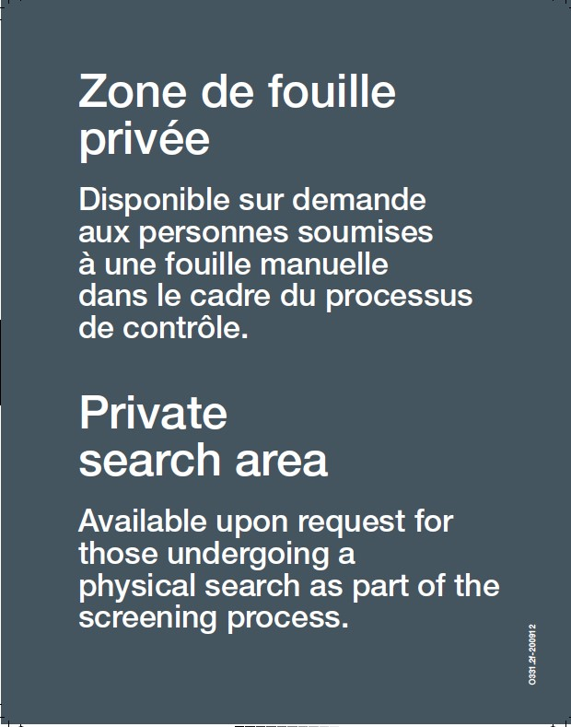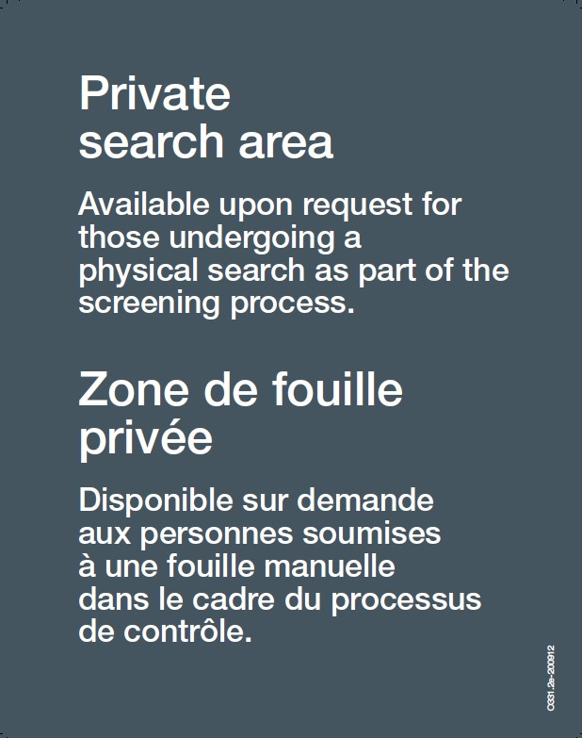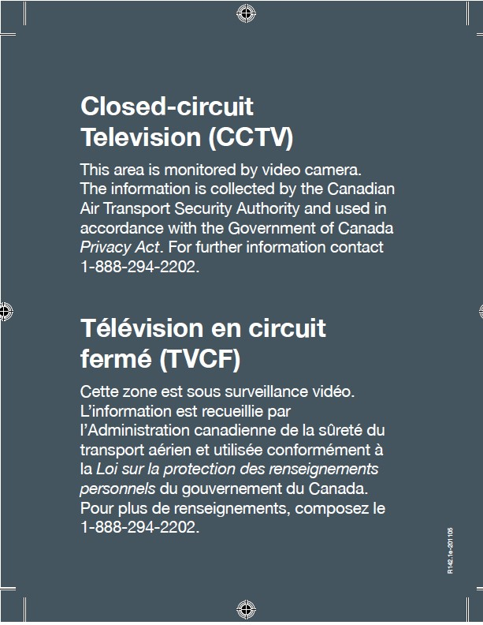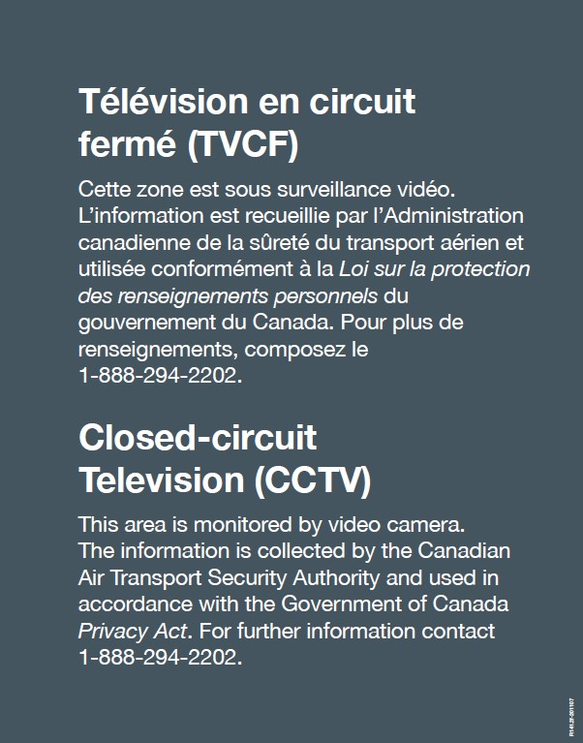
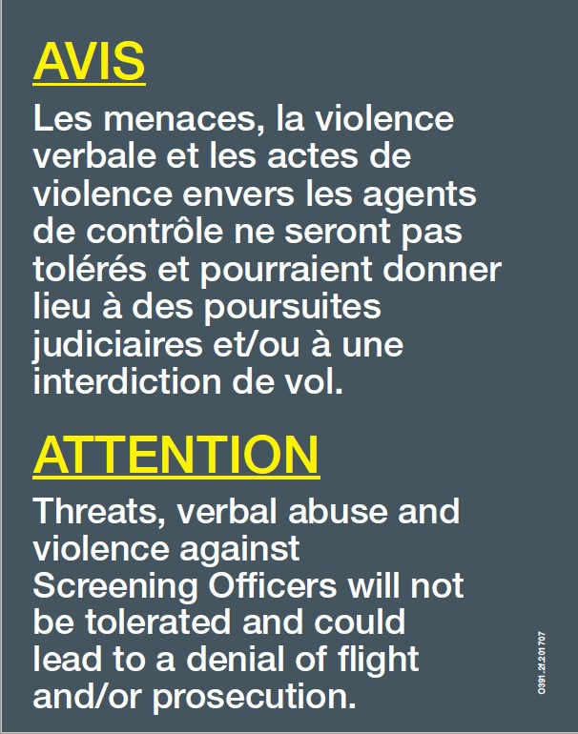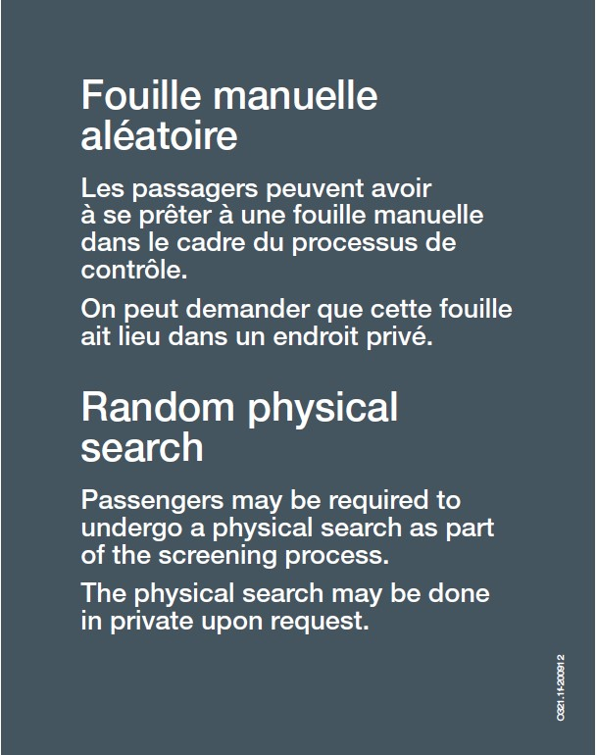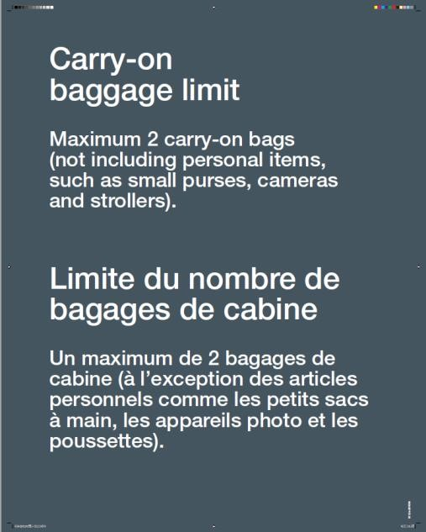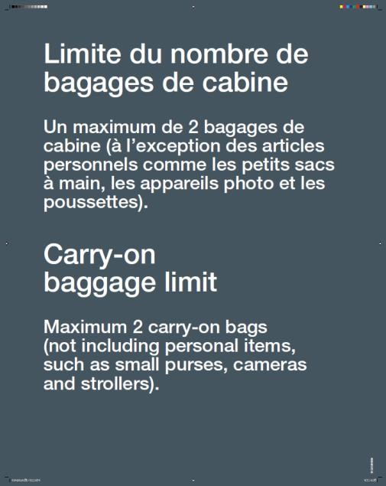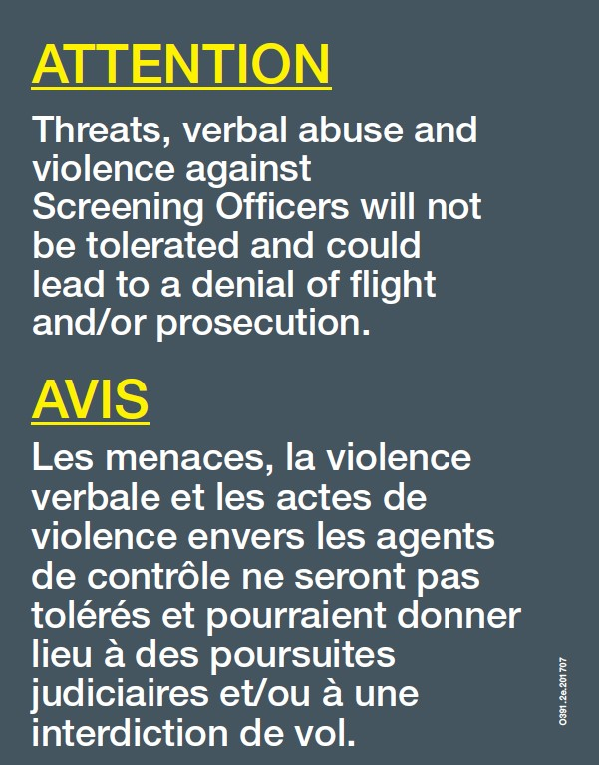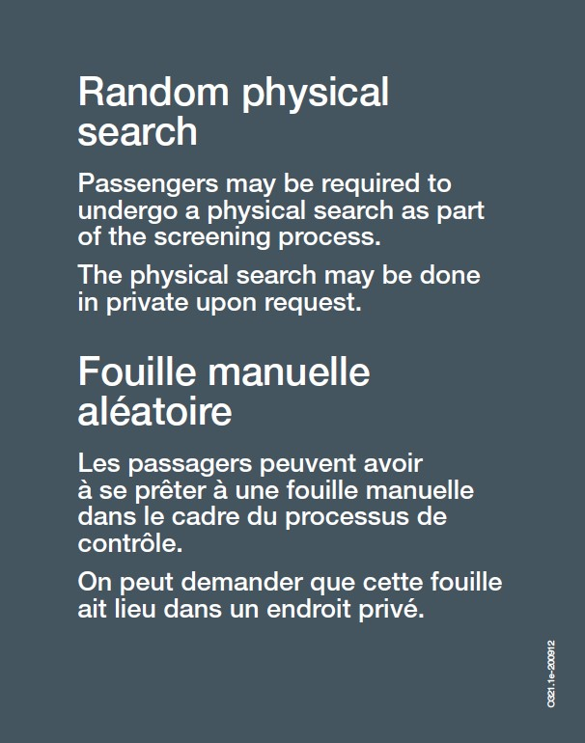

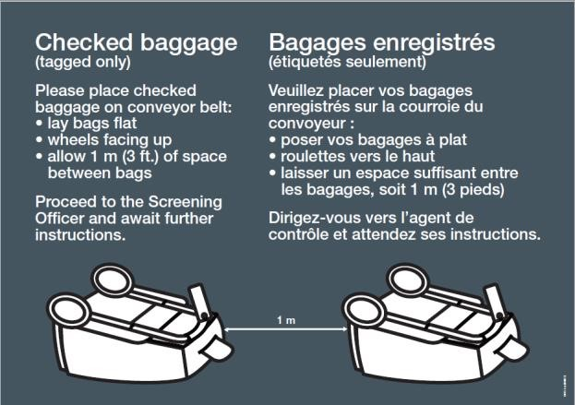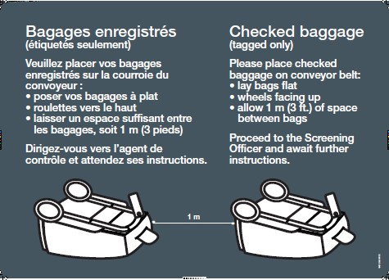
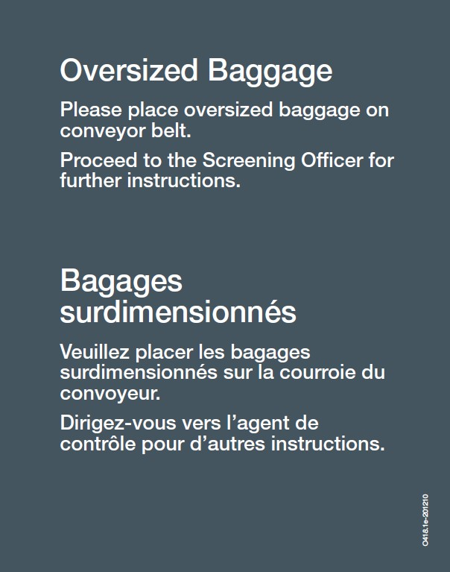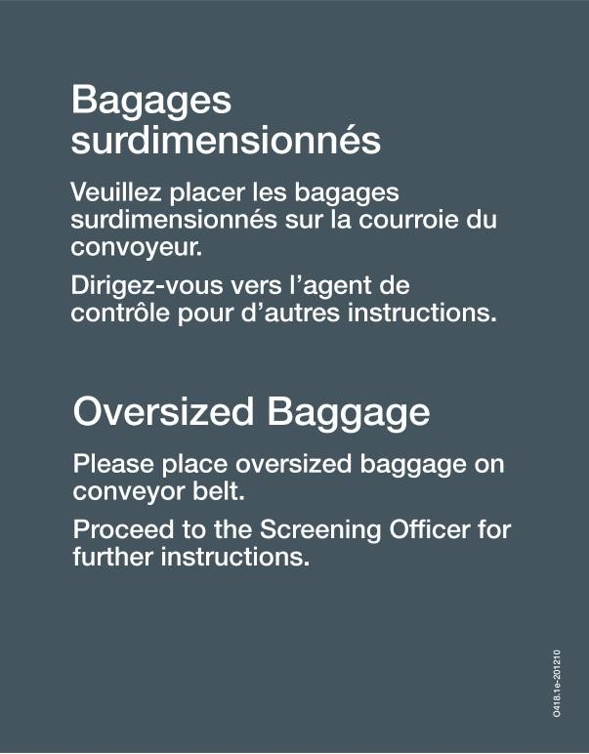

SCHEDULE B
Please see attached zip files.

SCHEDULE C

Treasury Board of Canada Secretariat / Secrétariat du Conseil du Trésor du Canada

October 16, 2023

To whom it may concern,

The Treasury Board of Canada Secretariat (TBS) wishes to signal support for the prototype developed by the Canadian Air Transport Security Authority (CATSA). The plasticized tactile booklet is intended to serve as an alternative accessible format for conveying information to the public that would otherwise be conveyed by signage.

The Communications and Federal Identity Policy Centre at TBS has responsibility for the mandatory standards governing the Government of Canada’s signage system – a system of 14 classes of sign applied to close to 35,000 facilities and engineered structures. We are actively engaged many of the current issues and discussions influencing signage including accessibility, inclusivity, and Indigenous reconciliation.

The Canadian Transportation Agency’s Accessible Transportation for Persons with Disabilities Regulations makes certain signage requirements of the Canadian Standards Organization’s CAN/CSA-B651 standard mandatory for CATSA and the Canada Border Services Agency. The 2023 update to the accessible signage provisions in the CAN/CSA-B651 standard no allows that “Alternative forms of communication can be considered, specifically for extensive information and guidance that might be issued by an individual enterprise or authority.”

We believe that CATSA’s prototype aligns with this concept of an alternative format to accessible signage bearing extensive information.

Yours sincerely,

Elizabeth Lindsay,
Executive Director,
Strategic Communications and Ministerial Affairs
INCA / CNIB
FRONTIER ACCESSIBILITÉ / FRONTIER ACCESSIBILITY

October 18, 2023

To whom This May Concern,

Canadian Air Transport Security Authority (CATSA) engaged CNIB Frontier Accessibility to provide a review of instructions booklets for accessibility, feedback, and recommendations. CNIB Frontier Accessibility assembled a team of 4 Lived User Experience Testers. Three were anglophone, one bilingual (English French). Two were low vision large print users, one large print user who was also a novice braille reader and one expert braille reader. All were white cane users; one was also a guide dog user.
They provided detailed feedback based on their lived experience on the following overall criteria:
- Braille quality
- Contrast
- Colour
- Letter size
- Booklet size
- Readability

The booklet was then reviewed against the best practices found in CNIB Clear Print
Guidelines: https://cnib.ca/sites/default/files/201807/CNIB%20Clear%20Print%20Guide.pdf
CATSA remediated the booklets and the same lived experience users provided their feedback suggesting no further changes.
It should be noted that the scope of this project was the booklets alone. Identifying additional potential solutions and assessing them for accessibility was not in scope. Based on tester feedback CNIB Frontier Accessibility finds that this can be a good alternative to signage in this case.
David Greenidge
Director of Operations
CNIB Frontier Accessibility
1929 Bayview Ave,
Toronto, ON M4G 3E8

Canada Border Services Agency / Agence des services frontaliers du Canada
VIA EMAIL

October 23, 2023

Canadian Transportation Agency
Ottawa ON K1A 0N9

To: Canadian Transportation Agency

RE: Letter Of Support for Canadian Air Transport Security Authority’s request for exemption under subsection 170(4) of the Canada Transportation Act from subsection 235(1) of the Accessible Transportation for Persons with Disabilities Regulations (ATPDR)

The Canada Border Services Agency (CBSA) places high importance on ensuring accessibility and equal service for all individuals and believes that if a passenger wishes to attain more independence, they should be afforded that choice.

The CBSA is also developing an alternative approach to conveying regulatory signage information to passengers with vision impairment in a tactile format that resembles the Canadian Air Transport Security Authority’s (CATSA) approach and believe that if CATSA and CBSA share this approach, it would
make it more effective since the passengers would not feel the need to readjust or rediscover the alternative signage. This would make it so that it takes less time and would be less stressful on the passenger, ultimately making it even more accessible.

The CBSA have viewed the prototype and consider it to be a positive advancement in quickly and easily providing regulatory information to those with vision loss. The prototype includes large print, raised print and braille versions of each regulatory sign. It also uses a high contrast colour scheme for improved readability. The CBSA supports this approach by CATSA.

Jag Johnston
Director General, Travellers Policy and Programs
Canada Border Services Agency

